AQIS METHYL BROMIDE FUMIGATION STANDARD

Version 1.7
November 2011

CONTENTS
Fumigant considerations – risk assessment, commodity, dosage, temperature 5
1.1 Risk assessment 5
1.2 Commodity (Non perishable) 5
1.3 Commodity (Perishable) 5
1.4 Dosage 6
1.5 Temperature 7
The fumigation site 8
2.1 Site requirements 8
2.2 Site floor 8
Consignment suitability for fumigation 9
3.1 Fumigant circulation 9
3.2 Fumigant penetration 10
The fumigation enclosure 11
4.1 Sheet fumigation 11
4.2 Using gas-tight containers as fumigation enclosures 12
4.3 Pressure testing requirements for un-sheeted containers 13
4.4 Chamber fumigation 14
4.5 Safety 15
Preparing the fumigation enclosure 16
5.1 Monitoring tubes 16
5.2 Fumigant supply pipes 17
5.3 Fans 18
5.4 Sand and water snake specifications 18
Calculating the dosage of fumigant required 19
6.1 Calculation of fumigation enclosure volume 19
6.2 Calculation of fumigant dosage 19
Performing the fumigation 20
7.1 Using a vaporiser 20
7.2 Distributing fumigant within the enclosure 21
7.3 Checking for leaks 21
Monitoring and maintaining fumigant concentrations 22
8.1 Monitoring frequency 22
8.2 Fumigant levels – Start-point and End-point 23
8.3 Fumigant concentrations 24
8.4 Topping-up 26
Completing the fumigation 27
9.1 Ventilation 27
9.1 Continued 28
9.2 Certification 28
APPENDIX 1: Fumigation of Perishable Commodities 29
APPENDIX 2: Fumigation of vessels with methyl bromide 33
1. PRIOR TO FUMIGATION 33
2. FUMIGATION PROCEDURE 34
2. Continued 35
2. Continued 36
2. Continued 37
2. Continued 38
2. Continued 39
APPENDIX 3: Commodities for which problems may occur when fumigated with methyl bromide 40
APPENDIX 4: Example of a record of fumigation 41
APPENDIX 5: Example of a fumigation certificate 42
APPENDIX 6: Pressure testing enclosures for gas-tightness 45
APPENDIX 7: Monitor tube placement for container fumigation 49
APPENDIX 8: Fumigant gas supply pipe systems 50
APPENDIX 9: Calculating the volume of differently shaped fumigation enclosures 51
APPENDIX 10: Vaporisers for methyl bromide 52
APPENDIX 11: Methyl bromide fumigation ready reckoner 54
APPENDIX 12: Examples of ‘Top-up’ calculations 55
APPENDIX 13: Methyl bromide as a quarantine fumigant 57
APPENDIX 14: Methyl bromide as an ozone depleting gas 58
APPENDIX 15: Glossary of terms 59

How to use this Standard

This standard is divided into two main sections:

- AQIS Requirements
- Descriptive Appendices

AQIS Requirements  AQIS requirements for this section are designed to be subject to audit during quality control procedures, either by AQIS, by other quarantine authorities or by authorised agents of either.  This section is divided into two main columns:  MANDATORY  This column lists conditions that MUST be achieved and actions which MUST be undertaken in order to conform to the requirements of the AQIS Standard.  INFORMATIVE  This column lists information that may be helpful to a fumigator in achieving the Mandatory Requirement. | Appendices  These appendices provide information on a range of issues that may be helpful to a fumigator on various aspects of the fumigation procedure.

MANDATORY |  | INFORMATIVE

Fumigant considerations – risk assessment, commodity, dosage, temperature

1.1 Risk assessment
1.1.1 Before commencing any fumigation process a risk assessment must be carried out. |  | The purpose of risk assessments is to ensure that any fumigation undertaken is carried out in such a way that minimises any Occupational Health and Safety (OH&S) risks, meets local regulations, protects the local population and the environment,and addresses potential adverse effects on the commodity being fumigated. A risk assessment may be written or visual, as appropriate

1.2 Commodity (Non perishable)
1.2.1 The commodity must be suitable for methyl bromide fumigation. | See the Import Conditions (ICON) database www.aqis.gov.au/icon for information on specific commodities. | Some commodities are unsuited to this treatment as they absorb large quantities of methyl bromide e.g oils, fats and finely ground materials. This may cause tainting or phyto-toxicity and may lead to hazards such as the presence of excessive bromide residues. This may result in the fumigated commodity not being suitable for its intended use.  If there is concern that a commodity may be adversely affected by methyl bromide, importers, exporters and fumigators should seek expert advice (outside of AQIS) regarding its effects or conduct tests on the commodity.  See APPENDIX 3: Commodities for which problems may occur when fumigated with methyl bromide. This table lists some commodities for which experts have found problems when fumigated with methyl bromide. This list is not comprehensive and is provided for guidance only.

1.3 Commodity (Perishable)
1.3.1 Fumigation of nursery stock must only be performed in Australia.  1.3.2 Fumigation of fresh flowers must only be performed in Australia (unless exemptions are in place). |  | Perishable commodities include cut flowers, fresh fruit, vegetables and nursery stock.  Additional requirements for the fumigation of perishable goods are set out in APPENDIX 1: Fumigation of perishable commodities

MANDATORY |  | INFORMATIVE

1.4 Dosage
1.4.1 Dosage must conform to:  - Permit conditions to import Quarantine Material into Australia;  - AQIS Import Conditions (ICON) database outside Australia;  - Quarantine Directions (within Australia). |  | Overdosing (the application of fumigant at rates above those specified by AQIS) to compensate for poor fumigation practice or inadequate equipment or sheeting should not be undertaken.  See the ICON database (www.aqis.gov.au/icon)
1.4.2 For the majority of commodities (excluding perishables) AQIS treatment dosages must be based on the anticipated minimum ambient temperature that the commodities inside the fumigation enclosure will experience during the fumigation period. |  | TABLE 1 :  COMMON STANDARD DOSAGE  FOR METHYL BROMIDE FUMIGATION
 |  | PEST/COMMODITY | REQUIRED CONCENTRATION
 |  | Giant African Snail | 128g/m³ at 21 °C for 24 hours at Normal Atmospheric Pressure (NAP)
 |  | Khapra Beetle | 80 g/m³ for 48 hours with a minimum concentration of 24 g/m³ after 24 hours at NAP
 |  | Stored Product Pest of Quarantine concern | 32 g/m³ at 21 ºC for 24 hours at NAP
 |  | Timber | 48 g/m³ at 21 °C for 24 hours at NAP

MANDATORY |  | INFORMATIVE

1.5 Temperature
1.5.1 Fumigation for quarantine purposes is not permitted if the ambient minimum temperature falls below 10 °C. |  | At temperatures below 10 °C the fumigant has decreased effectiveness against pests, and more of the gas may be absorbed by the commodity. Excessive fumigant uptake can pose an increased safety risk, as the gas is difficult to remove from the commodity.
1.5.2 Dosage must be compensated for temperatures below 21 °C. | For each 5°C (or part of 5°C) the temperature is expected to fall below 21 °C, 8g/m³ must be added to the dosage, unless otherwise specified by AQIS.  For example, using the standard dosage of 48g/m³ for a 24 hour exposure period, the dosage at:  21 °C and above is 48 g/m³  16 – 20 °C is 56 g/m³  11 – 15 °C is 64 g/m³  10 °C is 72 g/m³  The fumigation provider must record the temperature information on the fumigation certificate. | Minimum ambient temperature  The minimum ambient temperature that the fumigation enclosure is expected to experience over the duration of the treatment should be determined by checking with the official weather bureau in the country where the fumigation is taking place. This temperature should be used when determining the dosage. Alternatively, temperature recording equipment may be used to verify the temperature within the enclosure during the fumigation exposure period.  See APPENDIX 5: Example of a fumigation certificate.
1.5.3 Heating of fumigation enclosures. | The temperature in the fumigation enclosure must be raised above 10 °C during fumigation if the minimum temperature inside the enclosure is expected to fall below 10 °C. | Heaters incorporating a fan and thermostat may be used for this purpose. Flash proof heaters should be used if the commodity is flammable.  Consideration can also be given to storing and fumigating the commodity in heated warehouses during extended cold periods.

MANDATORY |  | INFORMATIVE

The fumigation site

2.1 Site requirements
2.1.1 The fumigation site must:  - Be able to be isolated from unprotected personnel.  - Be well ventilated.  - Be sheltered from high winds (as much as possible).  - Have a smooth gas impervious floor (see 2.2 Site Floor).  - Have a power supply available (either mains or generator). |  | The site should be protected from adverse weather conditions such as high winds that can affect fumigation performance.  Electrical power or a generator will need to be accessible on site, to run fans and heaters during fumigation treatments.

2.2 Site floor
2.2.1 The fumigation site floor must be impermeable to the fumigant if fumigation under gas proof sheets is to be carried out. | The floor of any site used for sheet fumigation must be:  - Flat and free of stones and other sharp objects so that a gas-tight seal can be made between the sheets and the floor;  - Free of cracks (including unsealed expansion joints in concrete floors) and drains or any other openings that will reduce the gas-tightness of the enclosure.  Where unsealed cracks or drains are present, they must be no closer than 1 metre from the fumigation enclosure. | Surfaces sealed with concrete or hot mix asphalt, that is, with a smooth surface finish that are in good condition and meet the requirements listed to the left, generally provide good floor surfaces for effective fumigation.  Where unsealed cracks exist in a floor intended for fumigation, they may be sealed with an impervious sealant.  Surfaces such as soil (including cement consolidated soil), sand, base rock and paving (stones or blocks) do not provide a suitable floor for a fumigation enclosure.  - On porous or unsuitable surfaces, floor sheets should be used for sheet fumigation;  - Gas proof sheets should be used or the floor should be permanently sealed;  - Plastic sheeting or paper containing a tar (asphalt) layer may be used for this purpose.

MANDATORY |  | INFORMATIVE

Consignment suitability for fumigation

3.1 Fumigant circulation
3.1.1 There must be sufficient free air space to circulate the fumigant and achieve uniform distribution throughout the enclosure. | The fumigator must be able to demonstrate that the required concentration of methyl bromide can reach the target of the fumigation by taking and recording concentration readings from representative points within the enclosure.  See 5.1 Monitoring tubes and,  7.2 Distributing fumigant within the enclosure | The free air space requirements for effective treatment of a consignment will vary depending on the commodity and the method of packing.  As a guide, there should be at least 350 mm of free airspace in total with 200 mm free air space above the commodity, 50 mm below and the remaining 100 mm at the sides and between the commodity.  Where commodities are stacked on the floor there must be sufficient free air space between individual items to allow the fumigant to act effectively on the target of the fumigation throughout the entire enclosure.  If there is insufficient space to allow the monitoring tubes to be positioned according to the requirements then it is unlikely that the consignment can be fumigated effectively.
3.1.2 Timber must be separated by a minimum of 5 mm of air space in one dimension every 200 mm. | The separators must allow for any sagging to ensure that the 5 mm minimum separation is maintained along the entire length of the timber.

MANDATORY |  | INFORMATIVE

3.2 Fumigant penetration
3.2.1 The target of the fumigation must not be wrapped in or coated with materials that are impervious to methyl bromide. | The fumigator must verify that the consignment is not wrapped in impervious materials that may prevent the methyl bromide from reaching the target of the fumigation.  The fumigator must verify that the target of the fumigation does not have impervious surfaces or coatings such as paints, lacquers and veneers that may prevent the effective penetration of methyl bromide.  Impervious wrappings such as plastic, tarred or waxed papers, aluminium foil etc. must be perforated, cut or removed prior to fumigation to allow the methyl bromide to reach the target of the fumigation. | If the consignment cannot be fully inspected for impervious materials because of problems with accessibility the fumigator can;  - Rely on a packing declaration from the supplier/shipper/ packer that describes how the consignment is packaged and what packing materials have been used that allows assessment of the consignment’s suitability for fumigation.  Or, if this documentation is not available;  - Contact another party that has sufficient knowledge of the consignment to obtain a written declaration that states that it is free from impervious surfaces or wrappings that would prevent an effective fumigation.  If suitable declarations cannot be obtained the container should be unpacked for inspection prior to fumigation. The inspection must be conducted either by the fumigator or by another party that subsequently provides the fumigator with a written declaration indicating that it is free from impervious surfaces or wrappings.
 | Impervious wrapping does not need to be cut or removed prior to fumigation if it conforms to the AQIS wrapping and perforation standard and is not more than one layer thick. | The AQIS Wrapping and Perforation Standard  To meet AQIS perforation requirements for fumigation impervious materials must contain not less than four (4) perforations of 6 mm diameter / 100 cm² (10 cm x 10 cm square) or five (5) perforations of 5 mm diameter / 100 cm². Plastic wraps containing numerous pinholes (at least 6 holes / cm²), frequently used for transportation of fruit and vegetables are also acceptable.
3.2.2 Untreated timber products must have at least one physical dimension which is less than 200 mm thick. | Timber products must be fumigated before any surface coating such as lacquering or paint is applied unless the product has at least one uncoated surface and a maximum thickness of 100 mm from the uncoated surface. | Methyl bromide will, in general, only penetrate 100 mm from the surface into timber within the fumigation exposure period.

MANDATORY |  | INFORMATIVE

The fumigation enclosure
FUMIGATION TREATMENTS FOR QUARANTINE PURPOSES MUST BE CARRIED OUT IN GAS-TIGHT ENCLOSURES

4.1 Sheet fumigation
4.1.1 Containers must be fumigated under gas proof sheets unless it can be shown that they comply with the AQIS pressure test standard for gas-tightness.  4.1.2 Prior to every treatment all fumigation sheets must be visually inspected for tears, holes and abrasions. These must be repaired or the sheet replaced. | For any sheet fumigation:  - Fumigation sheets must be positioned or protected with suitable padding to avoid any sharp corners or objects that might damage them;  - Sheets must be arranged so that there is at least 500 mm of sheet extending beyond the limit of the seal;  - In high winds, ropes or belts must be used to hold fumigation sheets in place to prevent them from flapping loose;  - Corners and areas where ropes, electrical leads, gassing pipes and monitoring tubes emerge from between or under the sheets must be tightly sealed;  - Loose fumigation sheeting on corners of stacks must be secured by folding, rolling and clipping to prevent blowing out in the wind;  - Where more than one container is being fumigated under sheet, at least one door of each container must be fully opened. | Joining fumigation sheets  Fumigation sheets can be joined by tightly rolling a 400 mm to 500 mm overlapped join, which should be secured by tight gripping welding style clips.  Joins should be made on, and supported by, a solid surface e.g. a container roof or wall.  When battens are used, there must be at least three to four full turns of the sheets around the battens and the rolled sheets must be held together with tight gripping clips.  To prevent joined sheets from coming apart they should be secured with weights or ropes.

MANDATORY |  | INFORMATIVE
4.1 Continued
4.1.3 The sheets must:  - Be free from any defects (for example faulty seams/welds, tears or holes);  - Have a permeability of less than 0.02 grams per square metre (of fumigation sheet) per 24 hours (multiplied by the dose in g/m³).  4.1.4 Sheets must be positioned to create a gas-tight seal with the floor. | Sand or water snakes used to seal the junction of fumigation sheets and the floor must be overlapped and positioned to prevent fumigant leakage. See 5.4 Sand and water snake specifications | Thinly coated, woven materials allow too much gas to be lost and are unsuitable as fumigation sheets.  Pool liners or annealed polypropylene sheets are also unsuitable as they allow methyl bromide to escape too rapidly.

4.2 Using gas-tight containers as fumigation enclosures
4.2.1 Pressure testing must be undertaken every time any container is fumigated without sheeting | If the decay time between 200 Pa and 100 Pa is less than 10 seconds, the container must be enclosed under a gas proof sheet before being fumigated with methyl bromide. | See APPENDIX 6: Pressure testing enclosures for gas-tightness.

MANDATORY |  | INFORMATIVE

4.3 Pressure testing requirements for un-sheeted containers
4.3.1 A pressure decay time from 200 to 100 Pa of 10 seconds or more must be achieved to certify that a container is gas-tight. | The pressure within the container must be raised to 250 Pa and the decay time from 200 Pa to 100 Pa must be measured.  The pressure decay time must be 10 seconds or more.  If a container does not pass this test then it must be enclosed under a gas-proof sheet before fumigation.  Containers which pass the pressure test may be fumigated with methyl bromide without enclosing them under gas proof sheets, and they must be treated as a sheeted enclosure from this point forward.  Care must be taken to ensure that monitoring tubes, fumigant supply pipes and electrical leads introduced into a container after the pressure test are adequately sealed to maintain a gas-tight condition. | To perform a pressure test, the pressure inside the closed container should be raised to 250 Pa using high-pressure compressed air supplied from a portable compressor or gas cylinder. As the pressure inside the container reaches 250 Pa, turn off the compressed air supply and:  - Allow the pressure to decay to 200 Pa;  - Start measuring the time (in seconds) when it reaches 200 Pa;  - Stop measuring the time (in seconds) when it reaches 100 Pa;  - Record the pressure decay time.

MANDATORY |  | INFORMATIVE

4.4 Chamber fumigation
4.4.1 A permanent chamber used for fumigation must meet the pressure test requirements. | A pressure test must be performed not less than twice a year. A general maintenance check must be performed at least once a year.  See 4.3 Pressure testing requirements for un-sheeted containers.  Door seals must be inspected before undertaking each fumigation treatment. | Chamber fumigation refers to fumigation treatments performed inside specifically designed chambers or permanently situated containers adapted for this purpose.  The following actions should occur before performing any chamber fumigation:  - Check that the chamber is not damaged and that there are no objects between the chamber and the chamber door to impair the seal;  - Visually inspect the door seals of the chamber and replace where necessary.
4.4.2 Monitoring tubes must be placed within the fumigation chamber. | See 5.1 Monitoring tubes.
4.4.3 Fumigant supply pipes must be placed within the fumigation chamber. | See 5.2 Fumigant supply pipes.
4.4.4 Fans must be placed within the fumigation chamber.  4.4.5 Where heating is required, a flash-proof heater(s) must be placed within the fumigation enclosure. | See 5.3 Fans  See 1.5 Temperature | NOTE  The use of an exhaust fan will aid in the ventilation of the chamber.

MANDATORY |  | INFORMATIVE

4.5 Safety
4.5.1 The fumigation enclosure and the surrounding area must be made safe for unprotected personnel.  4.5.2 A full-face respirator or self-contained breathing apparatus must be used when releasing fumigant and while working within the risk area after the fumigant has been released. | A ‘risk area’ must be set up with a minimum of 3 metres clearance around the sheeted fumigation enclosure in the open, or 6 metres clearance in an enclosed area, and warning signs put in place. The area must be cleared of any unprotected personnel, that is, personnel not wearing a respirator, and at no time during the fumigation treatment should unprotected personnel be allowed to enter the ‘risk area’.  Respirators must be fitted with a correct gas cartridge and specified by the manufacturer as suitable for methyl bromide (AX filter type). | Gas filter canisters should be used and replaced in accordance with the manufacturer’s instructions.

MANDATORY |  | INFORMATIVE

Preparing the fumigation enclosure

5.1 Monitoring tubes
5.1.1 All fumigations must be monitored. For enclosures larger than 30 cubic metres (equivalent to the average internal volume of a 20 ft shipping container), a minimum of three monitoring tubes must be positioned within the enclosure.  5.1.2 For enclosures smaller than 30 cubic metres, a minimum of one monitoring tube must be placed at the top centre of the commodity being fumigated.  5.1.3 For commodities not fumigated inside a container (e.g. large items of industrial and agricultural machinery, bagged grain, stacks of timber) the entire enclosed space within the fumigation sheets must be treated as a single fumigation enclosure. | Monitoring tubes must be placed as far as practicable from fumigant supply pipes.  ONE container must have one monitoring tube placed:  - at the top back of the commodity – as far from the doors as possible;  - as close to the centre of the commodity as is practicable;  - at the front base of the commodity.  TWO containers (in the one enclosure) must have one monitoring tube placed:  - at the top centre of the commodity in each container;  - at the front base of the commodity in either container.  THREE containers or more (in the one enclosure) must have one monitoring tube placed:  - at the top centre of the commodity in each container.  See APPENDIX 7: Monitoring tube placement for container fumigation. | Monitoring tube inlets should be at least 2 metres from the outlet of fumigant supply pipes.  Before placing monitoring tubes inside an enclosure, ensure that:  - Each monitoring tube can be identified through the use of tags or individually coloured tubes.  Fumigant monitoring tube specifications  Crush-proof nylon or hydraulic tubing or similar (3 mm external diameter and approximately 2 mm internal diameter) is effective for monitoring gas concentrations when containers and other enclosures are fumigated.  Care should be taken to ensure that:  - The monitoring tubes do not absorb methyl bromide;  - A free flow mixture of gas/air can be maintained;  - No kinks or blockages are present in the tubes; and  - Monitoring tubes extend beyond the boundary of the risk area.

MANDATORY |  | INFORMATIVE

5.2 Fumigant supply pipes
5.2.1 Fumigant supply pipes must be positioned to allow the fumigant to be introduced into the free air space around the commodity. | Fumigant supply pipes must be placed as far as practicable from fumigant monitoring tubes. | Monitoring tube inlets should be at least 2 metres from the outlet of fumigant supply pipes.  Sealing fumigant supply pipes  To prevent leakage from supply pipes:  - Make a gas-tight seal around every supply pipe exit point from the enclosure;  - Seal the exposed ends after the fumigant has been introduced into the enclosure.
5.2.2 Multiple containers under the one enclosure must have a fumigant supply pipe in each container. | Where multiple fumigant supply pipe systems are used, the entire system must be balanced in order to achieve even distribution throughout the enclosure.  In order to balance the system, each arm of the system must consist of fumigant supply pipes that are equal in total length and diameter. | Multiple fumigant supply pipes per enclosure  The use of multiple fumigant supply pipes will assist in distributing the fumigant when large enclosures or several containers in the one enclosure are treated.  Where the system is balanced, it is possible to effectively deliver all of the fumigant through the entire system simultaneously.  Where the system cannot be balanced, the correct amount of fumigant should be dispensed through each supply pipe in turn until the total amount of fumigant is applied.  See APPENDIX 8: Fumigant gas supply pipe systems.

MANDATORY |  | INFORMATIVE

5.3 Fans
5.3.1 Fans must be positioned to ensure that the fumigant is rapidly and effectively distributed throughout the fumigation enclosure.  5.3.2 For methyl bromide fumigation in small enclosures (such as freight containers), at least one fan must be used. For fumigation in larger enclosures, at least two fans must be used.  5.3.3 Where multiple containers are fumigated under the same sheets, fans must be placed in each container. | The fans must be switched on 10-15 minutes before the gas is introduced and for 30 minutes after the introduction of the methyl bromide, or until gas monitoring indicates that uniform gas distribution has been achieved. | Where high velocity and high volume fans are used, they should not run for longer than 15 minutes after the introduction of the gas, as they may force the fumigant out of the enclosure.  Fans should have a capacity to make at least 20 air changes an hour, taking into consideration the volume of the enclosure

5.4 Sand and water snake specifications
5.4.1 When using sand snakes, a minimum of two rows of sand snakes must be placed side by side with joins overlapping (like brickwork), and laid flush against the enclosure to create a continuous seal. | Sand snakes must be filled to only 65% - 75% with sand so that they lie flat on the fumigation floor. | Additional sand snakes may be placed on corners and other areas where fumigant leakage may be higher due to folds in the sheet or the presence of pipes or electrical leads.
5.4.2 When using water snakes a single, continuous water snake must be laid flush against the enclosure to create a continuous seal. | Water snakes must be filled to only 75% - 85% of capacity so that they lie flat on the fumigation floor. | If water snakes are used, the sheets should be weighed down and sealed using a single, continuous water snake placed flush against the enclosure. Particular attention should be given to ensure a complete seal where the ends of the water snake meet. Water snake placement should not start or end on a corner.

MANDATORY |  | INFORMATIVE

Calculating the dosage of fumigant required

6.1 Calculation of fumigation enclosure volume
6.1.1 The volume of a fumigation enclosure must be calculated from the measured dimensions. | When fumigating sheeted enclosures the measured external dimensions must be used  Where an enclosed un-sheeted container or chamber is used for fumigation, the volume of any gas circulation equipment external to the chamber must be included in the calculation of the enclosure volume, together with the known internal volume of the container or chamber  See APPENDIX 9: Calculating the volume of differently shaped fumigation enclosures. | The volume of most freight containers is commonly found on the outside of the container, but this measurement can only be used if the container is not sheeted and has been satisfactorily pressure tested.  See 4.3 Pressure testing requirements for un-sheeted containers.

6.2 Calculation of fumigant dosage
6.2.1 The dosage of methyl bromide applied to a fumigation enclosure must conform to the requirements of AQIS for the commodity and country of origin as found in the ICON database. | See www.aqis.gov.au/icon | To calculate the dosage (weight) of methyl bromide to be introduced into the fumigation enclosure, the following formula must be applied:  D = V x C  Where:  D = Dosage (in grams);  V = Volume (in cubic metres);  C = Required concentration (in grams per cubic metre).
6.2.2 Compensation must be applied to the dosage for fumigant mixtures containing less than 100% methyl bromide. |  | To calculate compensation for a mixture of 98% methyl bromide and 2% chloropicrin the following formula applies:  D = (V x C) ÷ 0.98
6.2.3 Compensation must be applied for temperatures below 21º C. | See 1.5 Temperature.

MANDATORY |  | INFORMATIVE

Performing the fumigation

7.1 Using a vaporiser
7.1.1 A vaporiser must be used for all fumigations conducted for quarantine purposes. | Methyl bromide must be applied to the fumigation enclosure in gaseous form. This must be achieved in all circumstances by applying the liquid fumigant through a vaporiser (HOT GASSING) in order to fully volatilise the fumigant prior to its entry into the fumigation enclosure.  See APPENDIX 10: Vaporisers for methyl bromide. | In warm or hot climates, ambient temperatures cannot be relied on to adequately vaporise liquid methyl bromide during the gassing process.  The water in the vaporiser unit should be raised to boiling point before any liquid methyl bromide is released into it. The water should be maintained at this temperature for as long as possible throughout the gas introduction process and should not be allowed to fall below 65 ºC to ensure complete vaporisation of the methyl bromide (and chloropicrin if present).  The temperature can be monitored during the gas introduction process by holding the gas supply pipe from the vaporiser to the fumigation enclosure. The pipe should feel warm/hot throughout the period in which the gas is introduced. If the temperature of the pipe reduces significantly, either stop the introduction of the fumigant and allow the water in the vaporiser to re-boil, or slow the flow of the fumigant from the cylinder to the vaporiser.  Complete fumigant vaporisation will allow more effective distribution and penetration of the fumigant, and will reduce the possibility of product damage and pest survival.

MANDATORY |  | INFORMATIVE

7.2 Distributing fumigant within the enclosure
7.2.1 Fans must be operating during the application of the fumigant to ensure even distribution within the enclosure.  7.2.2 Effective distribution of methyl bromide must be determined by monitoring gas concentrations at all monitoring points at set times after the introduction of the gas. |  | If all concentration levels cannot be achieved within 15% of the lowest reading (equilibrium) the fumigant should be redistributed by turning on the fan for a further period of time. Concentrations should then be measured to see if equilibrium has been reached.  This process should be continued until either equilibrium is reached or when the levels drop below the standard.  The fumigation cannot start if the fumigant levels drop below the standard concentration (A) as displayed in APPENDIX 11: Methyl Bromide Fumigation Ready Reckoner. If the cause can be identified and rectified without removing the sheet or losing excessive fumigant from the enclosure, the enclosure may be re-dosed and the fumigation process continued.

7.3 Checking for leaks
7.3.1 The fumigation enclosure and all application equipment must be free from leaks. | Checking for leaks must be carried out during the fumigant introduction process and after all the fumigant has been applied to the enclosure at the start of fumigation. | A small amount of fumigant should be released through the system prior to the release of the total dose. All joins and connections should be checked for leakage and corrective action taken, if required.

MANDATORY |  | INFORMATIVE

Monitoring and maintaining fumigant concentrations

8.1 Monitoring frequency
8.1.1 Methyl bromide concentrations within the fumigation enclosure must be measured on at least two occasions during the fumigation exposure period; at the start of the fumigation exposure period and at the end of the fumigation exposure period. |  | NOTE  The fumigation period begins when all the readings are at or above the standard concentration and equilibrium has been reached.
8.1.2 All instruments used for measuring and monitoring methyl bromide concentrations must be fit for the purpose, in good working order and calibrated on a regular basis according to manufacturer’s instructions.  8.1.3 All instruments used for measuring and monitoring methyl bromide concentrations within a fumigation enclosure must be fitted with a moisture absorption filter, an appropriate carbon dioxide (CO₂), or other filter, as required by the manufacturer. |  | Specifications for monitoring equipment  Monitoring equipment requires regular calibration and maintenance to ensure it operates effectively. It is particularly important to maintain carbon dioxide and moisture absorbers fitted to instruments (if applicable). Where batteries are used, they should be checked regularly for working condition.  Any monitoring equipment may be used providing it is capable of reliably measuring methyl bromide concentrations within the fumigation enclosure of between  2 – 100 g/m³ . However, it should be noted that the dosage required for some treatments will result in methyl bromide concentrations in excess of 100 g/m³ during the initial stages of the treatment.

MANDATORY |  | INFORMATIVE

8.2 Fumigant levels – Start-point and End-point
8.2.1 Fumigant concentrations must be measured at the start and end of the fumigation exposure period. | Fumigant concentrations must be measured at:  1. Start-point monitoring  The fumigation exposure period begins when the methyl bromide concentrations at all monitoring points are AT OR ABOVE THE STANDARD and have reached EQUILIBRIUM (when all readings are within 15% of the lowest reading).  2. End-point monitoring  Methyl bromide concentrations at all monitoring points must be AT OR ABOVE THE STANDARD at the end of the fumigation period, before fumigation can be declared successful.  See APPENDIX 11: Methyl Bromide Fumigation Ready Reckoner. | TABLE 2 : MONITORING TIMES
 |  | Exposure period | Start-point  monitoring | Mid-point monitoring | End-point monitoring
 |  | Less than 48 hours | Take the first readings once it is reasonable to expect that equilibrium has been achieved.* | Not required but may be undertaken | End of exposure period
 |  | 48 hours or more | Take the first readings once it is reasonable to expect that equilibrium has been achieved.* | 24 hours after start and as required. | End of exposure period
* Equilibrium can be achieved quicker if:
- There is good free air space in the enclosure
- The are sufficient fans and they are positioned to best effect
- The methyl bromide is applied as a hot gas.

MANDATORY |  | INFORMATIVE

8.3 Fumigant concentrations
8.3.1 Fumigant concentrations must be at or above the standard concentration (A) at all times, as set out in the Ready Reckoner. | See Appendix 11 Methyl Bromide Ready Reckoner  Some quarantine treatments require a higher retention rate than what is specified in this Standard. In such cases the higher retention rate is the end-point concentration that must be achieved for a successful fumigation.  This is most common for fumigations of perishable commodities where there is a short exposure time. | The concentrations presented in the ready reckoner are based on the required percentage retention in the following table:
TABLE 3:
STANDARD CONCENTRATIONS REQUIRED AT SPECIFIC
MONITORING TIMES
 |  | Monitoring times | Concentration of original fumigant required
 |  | 0.5 hours | 75% or more
 |  | 1 hours | 70% or more
 |  | 2 hours | 60% or more
 |  | 4 hours | 50% or more
 |  | 12 hours | 35% or more
 |  | 24 hours | 30% or more
 |  | 48 hours | 25% or more
 |  | See APPENDIX 11: Methyl Bromide Fumigation Ready Reckoner.
8.3.2 Fumigant concentrations at all monitoring points must be within 15% of the lowest concentration at the start of the fumigation exposure period. |  | If readings from the monitoring points are NOT within 15% of the lowest reading at start point, there may be a problem with:  - Inadequate fumigant distribution throughout the enclosure.  - Blockages in the monitoring tubes or other monitoring problems.  - Monitoring equipment (malfunction).  Where the problem is identified as inadequate fumigant distribution, the fan(s) should be turned on and run for a further period of 15-30 minutes and the readings retaken.  If fumigant levels are below the required standard concentrations at any time during the fumigation exposure period, in addition to the possible causes listed above, there may be a problem with:  - Fumigation sheets or fumigation floor.  - Gas-tight seals between sheets and floor.  - Highly sorptive commodity.  - Incorrect dosage.  If the cause can be identified and rectified without removing the sheet or losing excessive fumigant from the enclosure, the fumigation can continue as normal so long as concentrations are equal to or above the standard concentrations (A) as set out in the Ready Reckoner. See Appendix 11 Methyl Bromide Fumigation Ready Reckoner.  Additional fumigant may need to be added to top-up the concentration to a satisfactory level.  Where the cause cannot be readily identified (particularly in smaller fumigation enclosures, such as containers) fumigation should be stopped and the fumigant ventilated from the enclosure.  Once the area is safe (free of fumigant at levels hazardous to humans) the commodities and the enclosure should be inspected for possible causes.

MANDATORY |  | INFORMATIVE

8.4 Topping-up
8.4.1 Topping-up must only be undertaken when fumigant concentrations are above the minimum top-up level at all monitoring points.  8.4.2 Topping-up is not an option for fumigations of less than 12 hours. | When topping-up is done after the end point monitoring the exposure period must be extended for a further 4 hours and final monitoring readings must be taken and recorded.  The top-up dosage must be applied in accordance with Section 7: Performing the fumigation.  Topping-up is not an acceptable action solely to compensate for inadequate operational practices  e.g. use of torn or unsuitable fumigation sheets.  Topping-up must only be undertaken when fumigant concentrations are above the minimum concentration to allow top-up (B) at all monitoring points.  Fumigant levels must not be topped-up above the maximum top-up concentration (C).  In addition to the monitoring times in TABLE 2 monitoring must take place at intervals not greater than 6 hours apart throughout the fumigation period if it is suspected that the relevant final concentration will not be achieved. Monitoring at the set times must still be done. | There are two options available for topping-up methyl bromide:  Option 1 - Top-up – Start-point and End-point monitoring with top-up option at the end.  This option allows for topping-up the level of methyl bromide at the end of the fumigation period, but only in certain circumstances and only if fumigant concentration levels have been monitored according to TABLE 3.  If the fumigant concentration falls below the standard concentration (A) but not below the minimum concentration (C) indicated in APPENDIX 11: Methyl Bromide Fumigation Ready Reckoner. The fumigant levels may be topped up to not more than the maximum top-up concentration (B).  Option 2 - Top-up – Continuous monitoring with top-up options.  This option should be used when highly sorptive commodities have to be fumigated and the need for a top-up is indicated.  Commodities considered to be highly sorptive to methyl bromide include:  Fish Meals; Bone Meals; Corn Meals; Nuts; Seeds; Fats; Coffee Beans and commodities packed in polystyrene material.  See APPENDIX 12: Examples of ‘Top-up’ calculations.

MANDATORY |  | INFORMATIVE

Completing the fumigation

9.1 Ventilation
9.1.1 On completion of a fumigation treatment, the methyl bromide must be vented out of the fumigation container.  9.1.2 Ventilation of the enclosure must be conducted so that the workplace Threshold Limit Value (TLV) for methyl bromide is not exceeded outside of the risk area. | If there is the likelihood of exceeding the TLV, then the risk area must be extended beyond the recommended distance for the duration of the ventilation. | Ventilation of fumigation enclosures  This can be done by either natural aeration or forced ventilation using fans or other appropriate equipment.  The time taken to reach the TLV (5 ppm in Australia) may take longer than 48 hours, particularly when:  - Commodities are fumigated in 40 ft (12.2 m) containers;  - Commodities are tightly packed or sorptive;  - Free airspace around the commodity is less than a total of 350 mm.  Before measuring TLV, the fumigator should switch off all fans being used for aeration of the fumigation enclosure. Where containers have been sheeted, the sheet must be fully removed prior to testing for TLV. Where containers have been fumigated, fumigant concentrations should be sampled from one or more representative points from within the fumigation enclosure. After taking the samples the fumigator will close the enclosure and leave the risk area.  After 30 minutes of ventilation, the fumigator should reopen the enclosure and check the fumigant concentration inside the enclosure. If the concentration is less than or equal to 5 ppm, the enclosure may be declared safe. If concentrations of fumigant above 5 ppm are detected, the fumigator should leave the risk area, re-ventilate using fans or naturally ventilate the enclosure for a further period of time and recommence the TLV check procedure. This process should be repeated until all sections of the fumigation enclosure have been proved safe for re-entry.
Note
Commodities that have not been adequately ventilated threaten the health of people packing and inspecting fumigated commodities.
A notice may be placed on the container stating:
“Due to possible desorption of fumigant from the commodities within this container, further ventilation may be necessary before the container is entered and the commodities removed”

9.1 Continued
9.1.3 At the end of the fumigation exposure period, concentrations of methyl bromide in the fumigation enclosure, the air spaces of the treated commodity and the surrounding area must fall below the TLV.  9.1.4 The equipment used for measuring methyl bromide concentrations in ‘risk areas’ and post treatment clearance of enclosures must be fit for the purpose and capable of detecting concentrations of between 1 – 100 ppm v/v. | Before any unprotected personnel are allowed access to a fumigation enclosure and ‘risk area’ it must be declared free from hazardous levels of fumigant (at or below TLV).  Before a fumigated container or commodity is released from the control of the fumigator, it must be declared free from hazardous levels of fumigant (at or below TLV) in air spaces of the commodity or packing material enclosing the commodity.  Leak detection equipment must not be used for this purpose. | Where there is no documentation showing that an enclosure or container has been ventilated, handlers should treat it as still ‘under gas’ until it can be declared safe.

9.2 Certification
9.2.1 For offshore fumigations, fumigation providers must issue a certificate indicating the fumigation was successful and conformed to the AQIS standard. To support the claims made on the fumigation certificate, a Record of Fumigation sheet must also be completed on site and retained for audit purposes. |  | See APPENDIX 4: Example of a record of fumigation.  See APPENDIX 5: Example of a fumigation certificate.
APPENDIX 1: Fumigation of Perishable Commodities

In addition to the requirements described in the Methyl Bromide Fumigation Standard, perishable commodities fumigated to ICON and PHYTO database requirements must meet the following:

FRESH FRUIT AND VEGETABLES, NURSERY STOCK AND FRESH CUT FLOWERS

MANDATORY |  | INFORMATIVE
1. General conditions
1.1 Impervious wrappings or bags without perforations must be removed or opened.  1.2 The consignment must be prepared and stacked to allow effective fumigant circulation.  1.3 Cartons, boxes and other receptacles used to transport fumigated perishable goods must also be fumigated. | See Sections 6.1 and Section 6.2 of the Standard  See Section 8.3 of the Standard | If the plants are to remain in their original boxes or other packages, or are placed in other packages for fumigation, ensure that there is adequate ventilation by cutting holes or making numerous gaps in all sides of the packages.  The AQIS Wrapping and Perforation Standard  To meet AQIS perforation requirements for fumigation impervious materials must contain not less than four (4) perforations of 6 mm diameter / 100 cm² (10 cm x 10 cm square) or five (5) perforations of 5 mm diameter / 100 cm². Plastic wraps containing numerous pinholes (at least 6 holes / cm²), frequently used for transportation of fruit and vegetables are also acceptable.  NOTE  Methyl bromide concentrations may decline below an effective level when methyl bromide is used to treat commodities packed in polystyrene boxes.

MANDATORY |  | INFORMATIVE
2. Fresh fruit and vegetables
2.1 The temperature of the fruit pulp must be measured for dose calculations, not the minimum ambient temperature.  2.2 The lowest temperature recorded must be the temperature used to calculate the dose of methyl bromide for treatment purposes.  2.3 A carbon dioxide absorption tube or filter must be used in addition to a moisture absorption tube in specific circumstances. | The temperature must be measured by placing the temperature probe into the centre of a piece of fruit located in the middle of a carton. At least three temperature readings must be taken from fruit in three different cartons/pallets and from different varieties within the consignment:  - From one carton at the top of the pallet;  - From one carton in the middle of the pallet;  - From one carton at the bottom of the pallet. | Some commodities require specific minimum temperatures, e.g. New Zealand strawberries 18 °C.  Where appropriate, the commodity may be warmed to meet the minimum temperature requirement.  Some perishable commodities (e.g. garlic and onions) release high amounts of carbon dioxide and this affects gas measurements of some instruments. It is particularly important to maintain the carbon dioxide and moisture absorbers fitted to instruments. Where batteries are used, they should be checked for working condition.  Monitoring equipment requires regular calibration and maintenance to ensure that it is.

MANDATORY |  | INFORMATIVE
3. Nursery stock and fresh cut flowers
3.1 Pure methyl bromide must be used for nursery stock and fresh cut flowers.  3.2 Fumigation of nursery stock and fresh flowers must not be conducted below 11 °C or above 30 °C.  3.3 Plants that have been refrigerated or stored in a cool room must be brought up to ambient temperature of the enclosure prior to the introduction of methyl bromide.  3.4 Fans must be used to disperse the fumigant throughout the enclosure.  3.5 Where the lids of cardboard boxes are not sufficiently vented, the boxes must be opened and stacked to allow adequate gas circulation. | Chloropicrin is phytotoxic and must not be used.  See Section 1.5 of the Standard.  See Section 5.3 of the Standard. | Plants may be covered with single sheets of damp newspaper so that the gas is not circulated directly on to them.  The fumigation of plants above 30 °C should be avoided as plants may become stressed or damaged.  Plants should not be wet, but roots should be moist to prevent damage.  Low humidity during treatment may damage plants. Relative humidity in the fumigation enclosure should be held above 75% during fumigation.  In the absence of water misters within the fumigation chamber, damp newspapers and shallow trays of water may also be placed on the floor of the fumigation chamber to help prevent plant desiccation.  Excessive air currents during fumigation or the post-treatment aeration period aggravate injury. It is recommend that circulating and ventilating fans or blowers be operated for the minimum length of time required for distributing the fumigant evenly or for removing toxic concentrations after treatment.  Alternatively, flowers can be removed from the cartons and placed upright in the fumigation enclosure.  Some flowers, for example roses, may be imported with cardboard collars or plastic sleeves to prevent bruising during transport. These may be retracted or removed to allow effective gas circulation.

MANDATORY |  | INFORMATIVE
4. Post fumigation
4.1 Fumigated plants must not be packed into plastic boxes or boxes lined with plastic. |  | The original packing material may be used as long as it has been fumigated also.

APPENDIX 2: Fumigation of vessels with methyl bromide

Application
In addition to the requirements outlined in the AQIS Methyl Bromide Standard and ICON, the Yacht appendix is intended for the fumigation of vessels that can be sheeted or sealed for fumigation. See 4.2 Using gas tight containers as fumigation enclosures and 4.3 Pressure testing requirements for un-sheeted containers of the Standard.

THESE REQUIREMENTS APPLY TO VESSELS UNDER TWENTY FIVE (25) METRES IN LENGTH AND MAY BE APPLIED TO LARGER NON-COMMERCIAL VESSELS THAT CAN BE EFFECTIVELY SEALED. IT IS NOT INTENDED TO BE APPLIED TO THE FUMIGATION OF CARGO VESSELS.

MANDATORY |  | INFORMATIVE

1. PRIOR TO FUMIGATION
1.1 An assessment must be made to determine if the vessel can be effectively fumigated. | Timber components must not be covered or coated. See Section 3.2 of the Standard.
1.2 Due to the complex nature of vessel fumigations, a written plan for each fumigation must be submitted to AQIS for approval before fumigation commences. | The fumigator must visit the vessel to assess how it will be prepared and fumigated.  The written plan must contain the following information:  - Location of fumigation site  - How the vessel will be sealed/sheeted  - If the vessel is to be sealed, how it will be pressure tested  - The number and locations of fumigant supply pipes  - The number and location of fans  - The number and location of monitoring tubes  - The calculation of fumigant to be used and enclosure volume.  See Section 6.1 of the Standard. | The plan can be presented as a diagram with locations of supply pipes, fans and monitoring tubes clearly indicated.  The diagram does not have to be to scale, but needs to be legible and should indicate the fumigant enclosure volume accounting for volume reductions for any added fittings etc.  Yacht dimensions are usually provided in the owner’s manual.

2. FUMIGATION PROCEDURE
2.1 The fumigation site must be secured and a safety risk assessment must be undertaken. | If the vessel is to be fumigated on water, a ‘risk area’ must be set up around the fumigation enclosure or moored vessel (3 metres if achievable) with warning signs visible from all sides of the vessel. See Section 5.4 of the Standard.  Only authorised personnel are allowed within the risk area. The area must be cleared of any unprotected personnel, that is, personnel not wearing a respirator, and at no time during the fumigation should unprotected personnel be allowed to enter the risk area. | Proximity to other vessels should be taken into consideration when fumigating.  If the vessel to be fumigated is moored on a public jetty security personnel may be required.  Permission to fumigate may be required from the relevant:  - Harbour master  - Marina/Jetty  - Council  - Waterways  For containerised, dry dock, patent slip or flat rack fumigations refer to  Section 2.1 and Section 2.2 of the Standard.
2.2 If the vessel is to be fumigated on water, weather conditions, such as sea and wind conditions for the following 24 hours must be taken into account. |  | If the vessel is to be fumigated on a flat rack, refer to Section 2.1 and Section 2.2 of the Standard.  The weather conditions should be determined by checking with the Bureau of Meteorology to obtain the forecast applicable to the area where the fumigation will be performed.

MANDATORY |  | INFORMATIVE

2. Continued
2.3 If fumigating on water the sheeting of a vessel must be weighted and extend below the water to ensure an air tight seal (the sheet must be secure enough not to be affected by sea conditions).  2.4 If a vessel cannot be entirely sheeted, all windows, doors, hatches, ventilation points, entry/exit points, etc. must be made gas tight.  2.5 Sealed vessels must be pressure tested.  2.6 The vessel’s volume must be determined so that the correct amount of fumigant can be applied. | Prior to every treatment, any items used for sealing the vessel must be visually inspected for tears, holes and abrasions, as these are a major contributing factor to significant gas loss.  The entry/exit points for gas supply pipes and monitoring tubes must be made gas tight.  The cabin or area to be treated must be sealed with tape. Any bung holes need to be sealed and all foam rubber, beds, etc. must be removed.  See Section 4.2 and Section 4.3 of the Standard. | It is preferable to sheet the entire vessel/container as per Section 4.1 of the Standard. Multiple vessels/containers may be fumigated under a single gas proof sheet. If the sheet is unable to enclose the mast or superstructure, a seal must be secured to prevent gas leakage  Regardless of whether a vessel is sealed, containerized, individually sheeted or part of a multi-vessel fumigation, the fumigant supply pipe, fan and monitoring tube requirements in Section 5.1, Section 5.2 and Section 5.3 of the Standard apply.  Water proof does not necessarily mean gas tight.  See Appendix 6: Pressure testing enclosures for gas tightness of the Standard.

2. Continued
2.7 Fumigant supply pipes must be positioned to allow fumigant to be introduced and circulated effectively throughout the vessel.  2.8 Where multiple fumigant supply pipes are used, the entire system must be balanced in order to achieve even distribution throughout the enclosure. | See Section 5.2 of the Standard.  Minimum requirements for single storey vessels:  - One pipe per vessel less than 15 metres in length. The line should be centrally located (e.g. mid-ship).  - Two pipes per vessel greater than 15 metres in length. One line should be placed forward and one aft.  Minimum requirements for multi-storey vessels:  - One pipe per storey for vessels less than 15 metres in length. With due regard for internal lay out, the line should be centrally located (e.g. mid-ship).  - Two pipes per storey for vessels greater than 15 metres in length. With due regard for internal lay out, one line should be placed forward and one aft.  In order to balance the system, each arm of the system must consist of fumigant supply pipes that are equal in total length and diameter. | The size and design of a vessel will determine the number of fumigant supply pipes needed for effective fumigation.  Single storey vessels:  Single storey vessels are those with one accommodation deck with under-floor compartments that have a shared air space and a simple weather deck. Vessels with a distinct separate but simple wheelhouse on the upper deck could be treated as a single storey vessel. Vessels with one accommodation deck, but segregated by waterproof bulkheads broken into distinct spaces, may need to be treated separately.  Multi-storey vessels:  Multi-storey vessels are those that have separate floors/levels, including inhabitable levels. Vessels with a single storey that have storage and bilge areas under the floor should be treated as a single-storey vessel.  Complex or unusual vessels will often have distinct sealed bulkheads and storage compartments (for example: patrol boats, fishing vessels and pack ice vessels). When fumigating these types of vessels, these requirements should be taken into account to determine fumigant supply pipe numbers and placement. In some cases, there will need to be a fan, a supply pipe and a monitoring tube in each separate compartment.

MANDATORY |  | INFORMATIVE

2. Continued
2.9 Fans must always be used in vessel fumigations. | There must be enough fans situated in appropriate locations throughout the vessel, with enough capacity to adequately and evenly distribute the fumigant.  Fans are required for at least the first 30 minutes of the fumigation or until equilibrium and initial dose concentrations have been reached.  See Section 5.3 and Section 7.2 of the Standard.  Minimum requirements are:  Single storey vessels:  - One fan per vessel for small single cabin area vessels (e.g. cabin cruisers). The fan must be located adjacent to an injection line.  - Two fans per vessel between 15 – 30 metres in length. One fan must be placed forward and one aft.  - Three fans per vessel greater than 30 metres in length. One fan must be placed forward, one mid-ship and one aft.  Multi-storey vessels:  - Two fans per storey. One fan must be placed forward and one aft. | Fans should run sequentially to assist with the movement of the fumigant from areas where it has been introduced to areas where no fumigant supply pipe is present.  All doors and compartments should be opened to allow fans to be effective.  High velocity and high volume fans should not run for longer than 15 - 20 minutes after the introduction of the fumigant, as they may force the fumigant out of the enclosure.  The size and design of a vessel will determine the number of fans needed.

MANDATORY |  | INFORMATIVE

2. Continued
2.10 Vessels must have a minimum of three monitoring tubes per storey/level.  2.11 Inside the vessel, all monitoring tubes must be located at least 2 metres away from any fumigant supply pipes. | For fumigation under sheet, an additional monitoring tube must be placed outside the vessel, between the vessel and the sheet.  Minimum requirements are:  Single storey vessels:  Three tubes per vessel. Each vessel must have one tube placed as follows:  - Ceiling level forward  - Mid-ship around 1.5 metres above the floor.  - At or below floor level aft.  For vessels greater than 30 metres in length, four monitoring tubes are required.  These are to be situated as above, with the additional placed mid-ship – one in a cabin and one in a corridor, both around 1.5 metres above the floor.  Multi-storey vessels:  Three monitoring tubes per storey. Each storey must have one tube placed as follows:  - Ceiling level forward  - Mid-ship around 1.5 metres above the floor  - Below floor level aft (If it is not possible to place the tube below floor level it must be placed at floor level). | The size and design of a vessel will determine the number of monitoring tubes.

2. Continued
2.12 Dosage and Temperature | See Section 1.4 of the Standard.  See Section 1.5 of the Standard.  See Section 6.2 of the Standard.  See Section 8.3 of the Standard.  See Section 8.4 of the Standard.
2.13 Monitoring | See Section 7.3 of the Standard.  See Section 8.1 of the Standard.
2.14 Ventilation | See Section 9.1 of the Standard.

APPENDIX 3: Commodities for which problems may occur when fumigated with methyl bromide

Commodity | Notes
- Foodstuffs:  - Butter, lard and fats;  - Iodised salt stabilised with sodium hyposulphite;  - Full fat soybean flour, whole wheat flour, other high protein flours and baking powders;  - Nuts with high oil content;  - Certain baking sodas, cattle licks, salt blocks, or other foodstuffs containing reactive sulphur compounds;  - Bone meal. | Never exceed the recommended dosage or exposure periods for food or foodstuff commodities.  Foods imported into Australia or manufactured in Australia must comply with the Food Standards Code  www.foodstandards.gov.au.
- Leather Goods | Particularly kid or other leather goods tanned with sulphur processes.
- Woollens | Extreme caution should be used in the fumigation of Angora woollens.  Some adverse effects have been noted on woollen socks, sweaters, shawls and yarn.
- Viscose rayon | Rayons processed or manufactured with the use of carbon bisulfide.
- Photographic chemicals | Excluding camera film or X-ray film.
- Paper:
- Silver polishing papers;
- Certain writing and other papers cured by sulphide processes;
- Photographic prints;
- “Carbonless” carbon paper;
- Blueprint papers.
- Rubber Goods:
- Sponge rubber;
- Foam rubber, such as rug padding, pillows, cushions, mattresses, and some car seals;
- Rubber stamps and other similar forms of reclaimed rubber.
- Vinyl
- Furs
- Feathers | Especially in feather pillows.
- Rug Padding | e.g. foam rubber, felts, etc.
- Charcoal, cinder blocks and activated carbon
- Horsehair articles
- Oil artworks
- Sulphur-based paint
- Cellophane
- Polystyrene packaging and containers | Polystyrene can absorb large quantities of methyl bromide, which may take a long time to desorb.

APPENDIX 4: Example of a record of fumigation
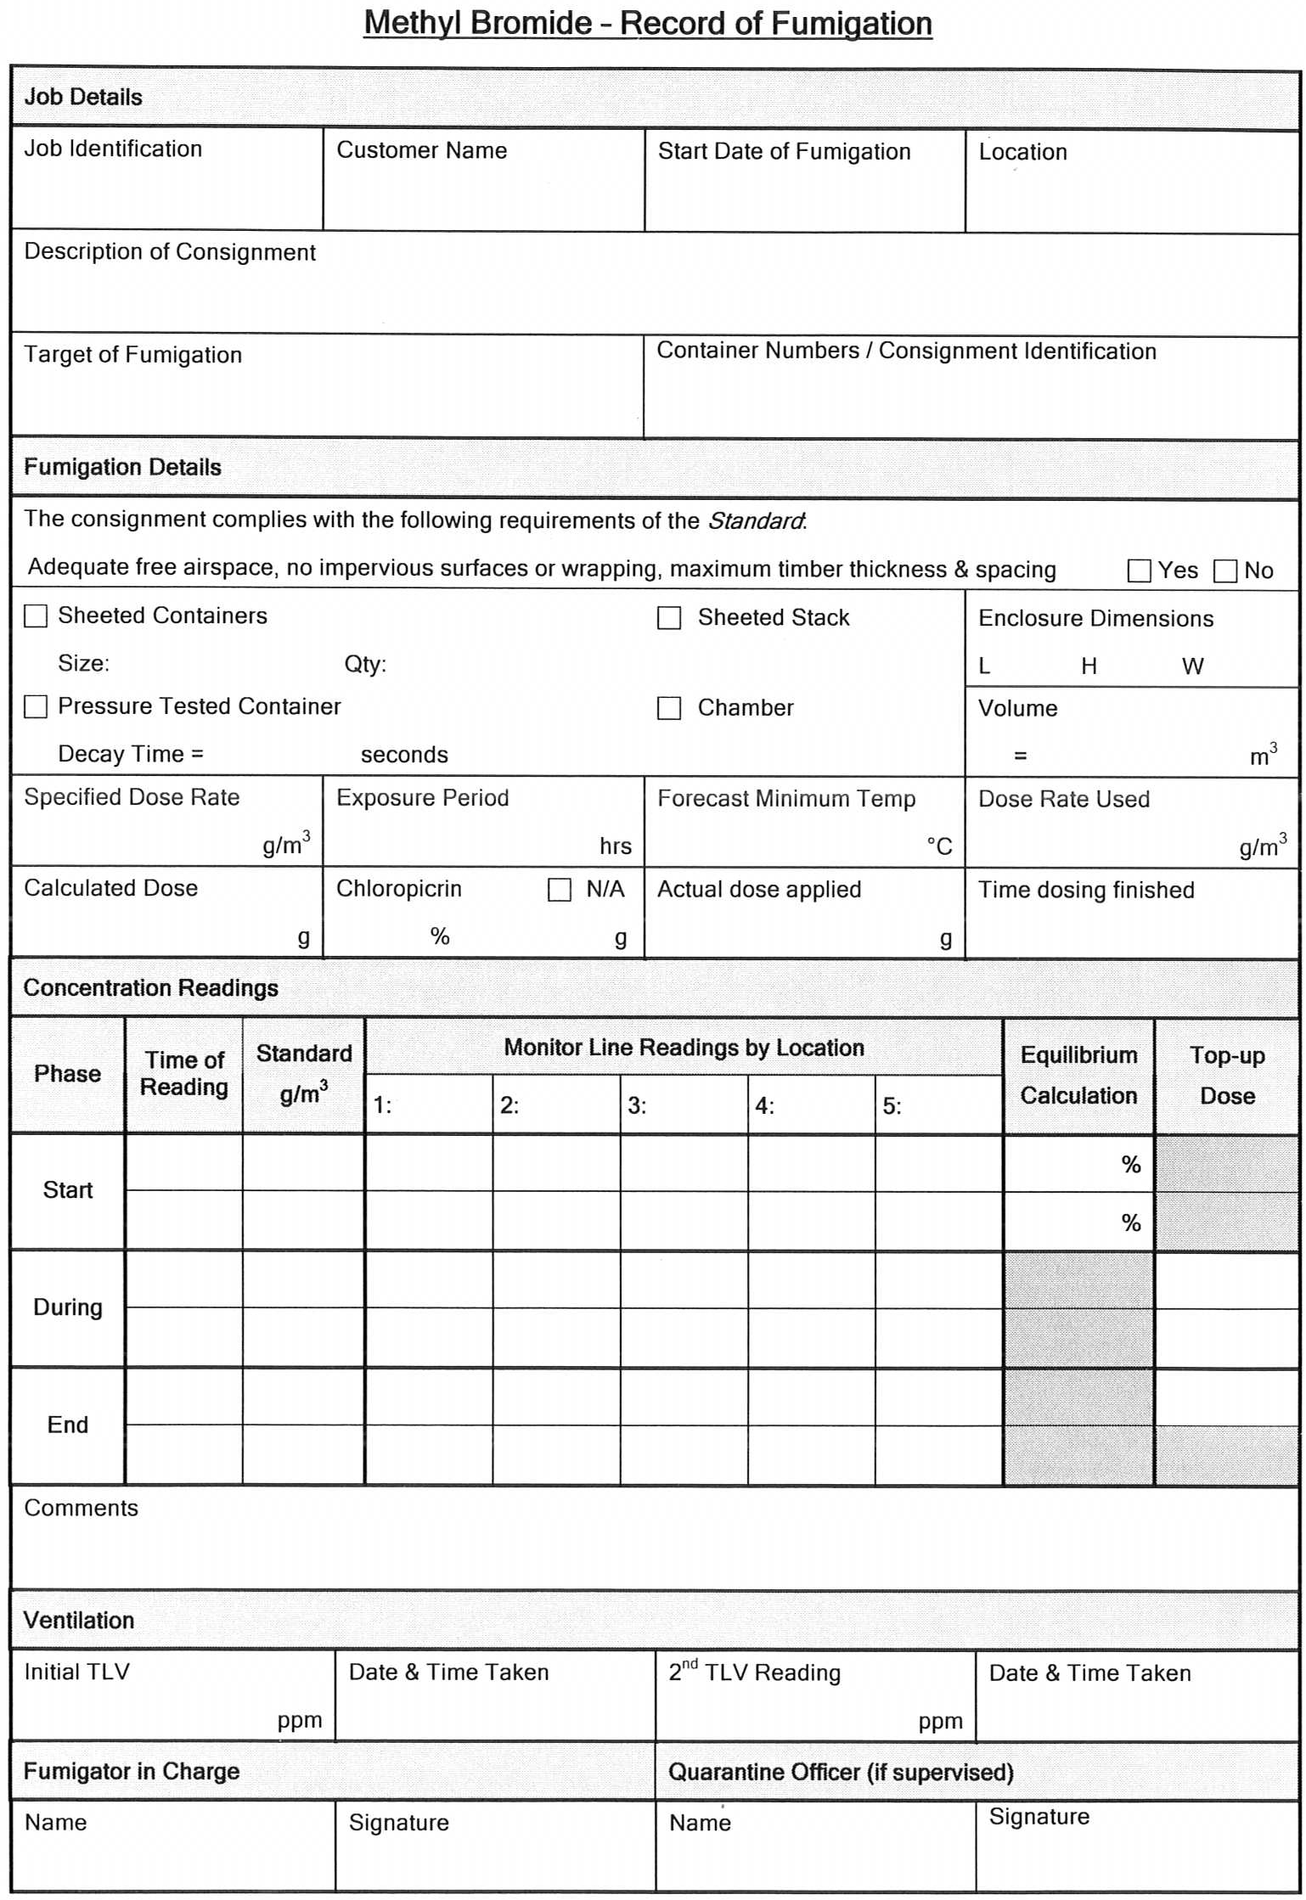
For a copy go to http://www.daff.gov.au/aqis/import/general-info/qtfp/treatments-fumigants
APPENDIX 5: Example of a fumigation certificate
For a copy go to http://www.daff.gov.au/aqis/import/general-info/qtfp/treatments-fumigants
How to complete the AFAS Approved Standard Fumigation Certificate
Details of the consignment and information relating to the fumigation must be included on the fumigation certificate for it to be accepted by AQIS. This information should be on a single page and in a format consistent with the above template. Following is advice on completing this fumigation certificate template.
Only fumigation certificates from AFAS countries issued by a treatment provider on the AFAS Acceptable Treatment Providers list will be accepted by AQIS.
Certificate must be on the treatment provider’s letterhead
The letterhead must include the address of the fumigation treatment provider that matches the address published on the AQIS treatment providers list (TPL). Where a company has more than one branch the address on the letterhead must match that on the TPL for the branch that issues the certificate.
Certificate Number / AFAS Registration Number
Each certificate must include a unique certificate number issued by the treatment provider and the treatment provider’s AFAS Registration Number. For audit and investigation purposes the certificate number must link to the treatment provider’s fumigation records for the treatment covered by the certificate.
Target of the Fumigation Details
Select the option that best describes the target of the fumigation. This may be the commodity (goods), the packaging (including pallets and/or container) or both.
Consignment Link
The certificate must include a link to some other official documentation related to the consignment such as: a bill of lading number, a commercial invoice number, a preferential tariff certificate number, a packing list number, a letter of credit number or container number. If there is insufficient room on the certificate you may use the additional declarations field or attach a complete list to the certificate.
Consignment Details
The certificate must also include the quantity, the country of origin, the intended port of loading and country of destination as well as the name and addresses of the exporter and importer.
Treatment Details
  - Date fumigation completed: is the date on which the fumigation exposure period is complete.
  - Place of fumigation: is the general location in which the fumigation took place, e.g. Town / City.
  - AQIS prescribed dose rate (g/m³): is the AQIS prescribed concentration of methyl bromide (MBr) required to effectively treat the target of the fumigation.
  - Exposure period (hrs): is the AQIS prescribed duration of the fumigation.
  - Forecast minimum temperature (°C): is the minimum temperature in degrees Celsius forecast by an official source for the period of fumigation.
  - Applied dose rate (g/m³): is the concentration of MBr applied to the fumigation enclosure including adjustments made to the AQIS prescribed dosage to compensate for forecast minimum temperatures between 21°C and 10°C.
  - How was the fumigation conducted: Select the fumigation enclosure type and include container number/s if the treatment was conducted in the container/s the target of the fumigation will be shipped in.
  - Does the target of the fumigation conform to the AQIS plastic wrapping, impervious surface and timber thickness requirements at the time of fumigation? This declaration identifies that at the time of fumigation all AQIS plastic wrapping, impervious surface and timber thickness requirements have been met. If there is no plastic wrapping or impervious surfaces on the target of fumigation, the fumigator should answer ‘yes’ as all plastic wrapping and impervious surface requirements are met. Where there requirements are not met the fumigation should not be conducted.
  - Ventilation, final TLV reading (ppm): The final threshold limit value (TLV) reading is when the methyl bromide concentration within the enclosure falls to 5 ppm or below. Record the MBr concentration reading to declare the enclosure is gas free. Where multiple containers are fumigated in one enclosure, TLV is required for each container. Where a stack or permanent chamber fumigation is performed, answer ‘NA’ (not applicable) as no TLV is required.
Declaration
The AFAS accredited fumigator (or accredited officer if the certificate is endorsed by the relevant regulatory authority) responsible for ensuring that the treatment is effective and performed according to the requirements of the AQIS Methyl Bromide Fumigation Standard must sign and date the certificate and print their name and accreditation number. They may also wish to stamp the certificate with their company stamp.
Additional Information
Any additional information that the fumigator wishes to supply may be included in the Additional Declarations field.
False declarations may result in AFAS accreditation being revoked.

APPENDIX 6: Pressure testing enclosures for gas-tightness

All fumigations must be conducted in gas-tight enclosures. Where it is not intended to enclose the commodity in gas-proof sheets, the gas-tightness of the enclosure must be determined prior to the introduction of any fumigant.

Inspection of empty containers

If a container can be selected prior to packing, the procedure below should be followed.

The container should be positioned to allow easy access to all four sides and the roof. It should stand on a flat, horizontal surface to avoid twisting (or racking) that may prevent the doors from providing an adequate seal.

The container should be examined before pressure testing to ensure it is structurally sound, the sides and roof are free of significant holes, and free of obvious distortion. Containers that are obviously damaged (e.g. where large holes and gaps are present in the roof and walls, or where the doors, door seals and locks do not fit and function properly) are not suitable and should not be pressure tested.

Where rust is present, the affected areas should be closely inspected and checked for the presence of holes. Containers with holes, gaps or those that are badly rusted are not suitable for pressure testing. The doors must make firm contact with each other, the doorframe and floor sill so that their seals function effectively. The rubber seals around the doors should be unbroken, leaving no obvious gaps. Containers with faulty doors and door seals are unsuitable for pressure testing.

The interior of the container should be examined from inside, with the doors closed so that any gaps or holes should be visible as they will allow light to enter the container. Containers with any holes and gaps are unsuitable for pressure testing.

Containers with:
- Wet or damaged floors are not suitable for pressure testing;
- Dry floors that are in good condition showing no signs of damage are suitable for pressure testing.

Closing the ventilators

All ventilators must be sealed on the outside of the container – not the inside.

Make sure the area around each ventilator is dry and free from grease, then completely cover and seal all ventilators to make them gas-tight. The most effective way to seal ventilators is to completely cover them with plastic duct tape.

It is important to unseal all ventilators at the end of the exposure period – and always before the container is loaded onto any form of transport.

Pressurising the container

This should be done without drilling holes through the walls of the container.

AQIS recommends a ‘finger manifold’ be used for pressure testing.

The finger manifold is designed to deliver high pressure compressed air into a container, rapidly pressurise it and then allow the pressure decay time to be measured. The manifold has twelve ‘fingers’, nine of which deliver compressed air into the container while the other three measure the pressure within the container. The ‘fingers’ are made of soft copper tubing that can be bent to shape as necessary.

The manifold is bent to fit over the front of the sill so that it can be sealed between the right hand door and the sill, and removed after the pressure test has been completed.

Instruments for measuring the pressure decay time

The pressure inside the container can be measured using a variety of instruments. The equipment required ranges from relatively simple to proprietary instruments including:
- A simple U tube manometer or an inclined manometer, using a manually operated stop watch;
- Any sensitive pressure gauge, using a manually operated stop watch;
- A purpose made instrument, the CONTESTOR, which combines a pressure sensor with a timer that cuts in when the required pressures have been achieved.

Procedure for pressure testing

Make sure the area around the container ventilator is dry and free from grease, then completely cover and seal all ventilators to make them gas-tight.
The pressure inside the closed container must be raised to 250 Pa using high-pressure compressed air supplied from a portable compressor or gas cylinders.
- As the pressure inside the container reaches 250 Pa, turn off the compressed air supply.
- Allow the pressure to decay to 200 Pa.
- Start measuring the time (in seconds) when it reaches 200 Pa.
- Stop measuring the time (in seconds) when it reaches 100 Pa.
- Record the pressure decay time.

NOTE
AQIS considers containers that give a pressure decay time from 200 to 100 Pascals of 10 seconds or more to be gas-tight. Such containers may be fumigated with methyl bromide without enclosing them under gas proof sheets. Where the pressure decay time does not meet the minimum requirements, the container must be enclosed in gas proof sheets.
FIGURE 1 –FINGER MANIFOLD FOR DELIVERING HIGH PRESSURE COMPRESSED AIR INTO A CONTAINER AND MEASURING THE PRESSURE INSIDE THE CONTAINER.

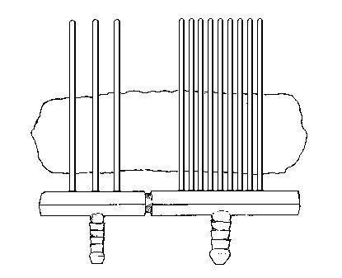

The ‘finger manifold’ is designed to deliver compressed air into a container, pressurise it and allow the pressure decay to be measured. The manifold (illustrated above) has twelve ‘fingers’, nine of which deliver compressed air into the container, while three measure the pressure within it. The ‘fingers’ are made of soft copper tubing that can be bent to shape as necessary.

The manifold can be bent to fit either over the front of the sill or between the vertical door seal. In either case sealant is applied between the fingers of the manifold and door seals and removed after the pressure test has been completed.
FIGURE 2. TECHNICAL DRAWING OF THE FINGER MANIFOLD FOR PRESSURE TESTING FREIGHT CONTAINERS.

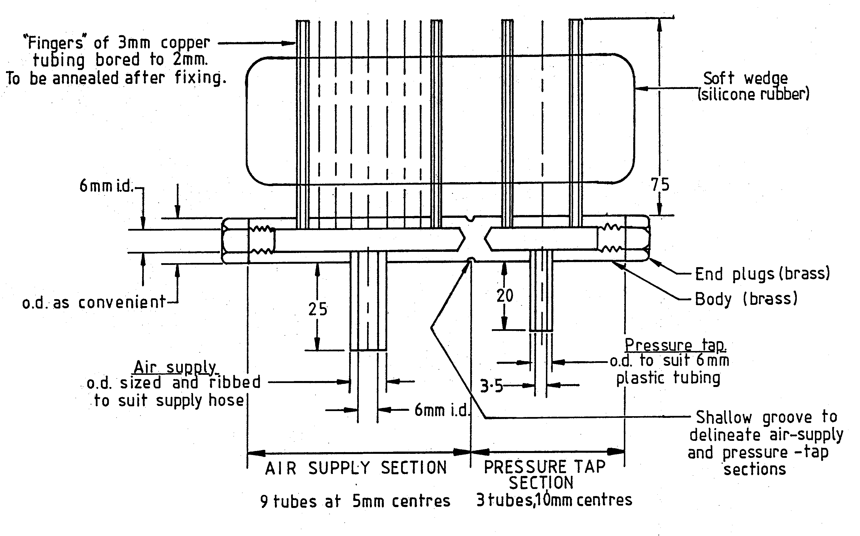

APPENDIX 7: Monitor tube placement for container fumigation
One container in one enclosure
Three gas monitoring points
(1) Top back (2) Middle centre (3) Front base

Two containers in one enclosure
Three gas monitoring points
One top centre of the commodity in each container, one front base of either container

Three or more containers in one enclosure
One gas monitoring point at the top centre of the commodity in each container

APPENDIX 8: Fumigant gas supply pipe systems
When gas is introduced into an enclosure through multiple supply pipes of differing length or diameter, the amount of gas flowing through each pipe will vary due to friction between the gas and sides of the pipe, as well as the flow dynamics of the gas.
Arrangements of gas supply pipes for single and multiple manifold systems to ensure balanced distribution of fumigant gas into the fumigation enclosure.
Complex
Systems

These examples demonstrate possible methods of creating balanced systems for distribution of fumigant gas.

Multiple manifold systems are the most adaptable, allow for quick, safe and effective fumigation and are recommended.
Multiple Manifold Systems
M – Volumetric measuring device (dispenser) or scales.
Single Manifold Systems

The overlying principle is that a balanced system will distribute the same volume of gas through each arm of the system at the same time. If it is not possible to achieve a balanced system then balanced application must be achieved by distributing measured amounts of gas through each arm of the system in turn.

APPENDIX 9: Calculating the volume of differently shaped fumigation enclosures

The following guidelines may be used to assist in calculating the volume of differently shaped fumigation enclosures:

D
H
Shape 4
Shape 1
Shape 2
Shape 3
D
H
H
D
Shape 5
L
W
H
W
L
H

The internal volume of a fumigation enclosure can be calculated by adding up the volume of its parts where:

L = Length W = Width H = Height
R = Radius (Diameter/2) D = Diameter (Radiusx2)
π (Pi) = 3.142

Volumes are:

Shape 1 (triangular prism): 1/2(L x W x H)
Shape 2 (rectangular prism): L x W x H
Shape 3 (dome): 2/3(π x R x R x R)
Shape 4 (cone): 1/3(π x R x R x H)
Shape 5 (cylinder): π(R x R) x H

APPENDIX 10: Vaporisers for methyl bromide

The following is a design for a simple yet sophisticated vaporiser that can be made cheaply with locally available components.

The following materials and methods are required:

The Heat Transfer Coil

The coil should be made from copper tubing and should be at least 12 metres long. It can be made from one continuous length of copper tubing (12 mm in diameter [ID]). However, a much faster gas flow can be achieved by constructing it from three five metre lengths of tubing of increasing diameter; 6 mm ID, 9 mm ID and 12 mm ID, for example. The system illustrated below (Diagram 1) will allow the gas to escape quickly through the outlet, avoiding excessive back-pressure, which can slow down gas flow from the cylinder.

The whole system should allow for at least 0.1 square metres of tubing surface for every kilogram of fumigant to be vaporised each minute.
Diagram 1

The lengths of tubing must be carefully joined in a manner that is completely gas-tight. Suitable connectors should be fitted to the inlet and outlet to meet the requirements of the gas inlet and outlet pipes. This instruction shows the use of a manifold with four outlet taps that easily allow for a balanced system to fumigate up to four or more containers at the same time, ensuring that the same amount of gas is introduced to each.

The manifold should be constructed from 19 mm to 24 mm tubing, with suitable gas taps and outlets fitted.

The tubing should be coiled as tightly as possible to allow for the coil to fit into a suitable water container. The inlet and outlet ends should be positioned above the top segment of the coil so that they are clear of the water bath (see Diagram 2).

The Water Container

Stainless steel sheet 1.6 mm thick should be used to construct the water container and cowling because mild steel sheet rusts very rapidly. Handles should be provided to allow for lifting.
Diagram 2

A cowling should be included to support the container above the gas burner and to protect the burner from the wind.

The Gas Burner

A three-ring gas burner of the type used for boiling large food pots is satisfactory.

Care should be taken to use a burner that can be adjusted to burn with a hot flame, to ensure that adequate heat can be applied to the water container both before and during the application of the fumigant.

Fittings

The choice of fittings for both inlet and outlet will depend on the individual and the equipment used.

However it is strongly recommended that good quality, gas rated fittings are used. Threaded fittings on all gas piping is strongly recommended, rather than relying on hose clamps to hold piping in place on bare copper tubing.

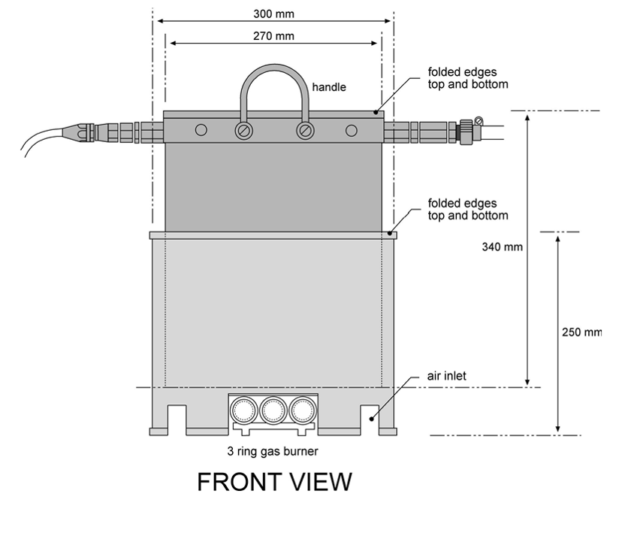
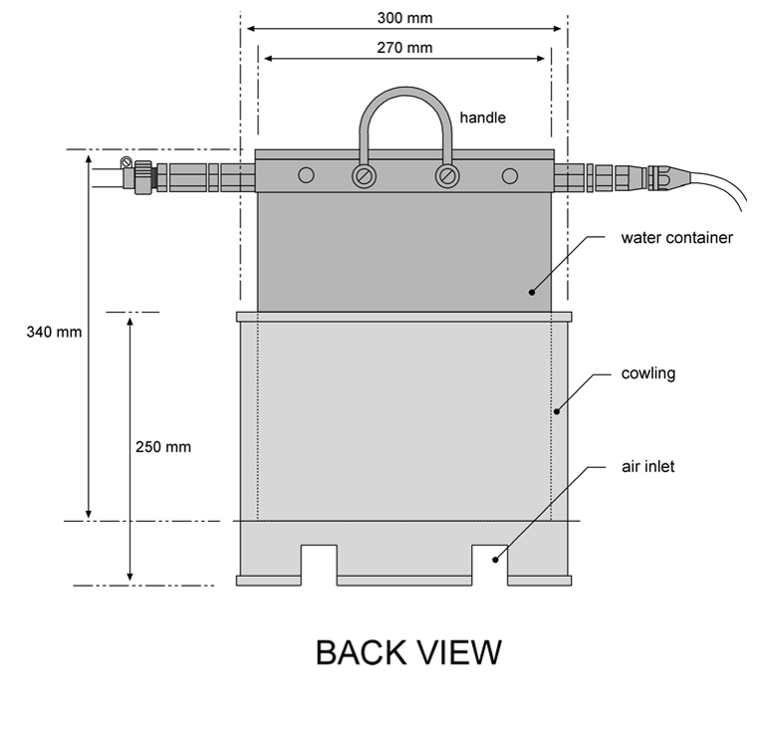

APPENDIX 11: Methyl bromide fumigation ready reckoner
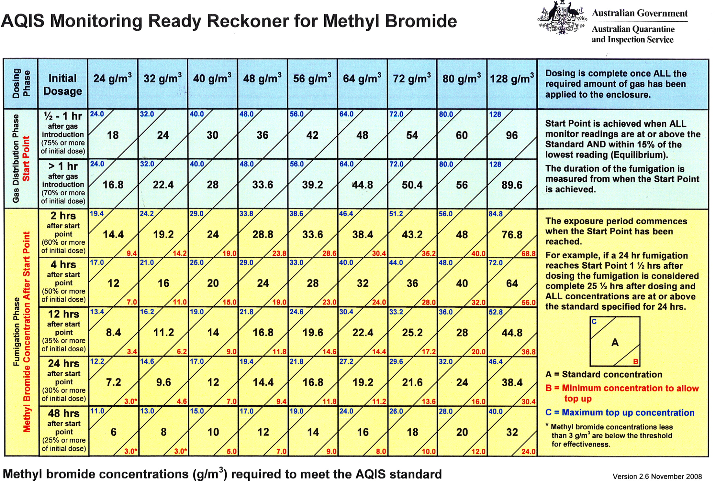

APPENDIX 12: Examples of ‘Top-up’ calculations

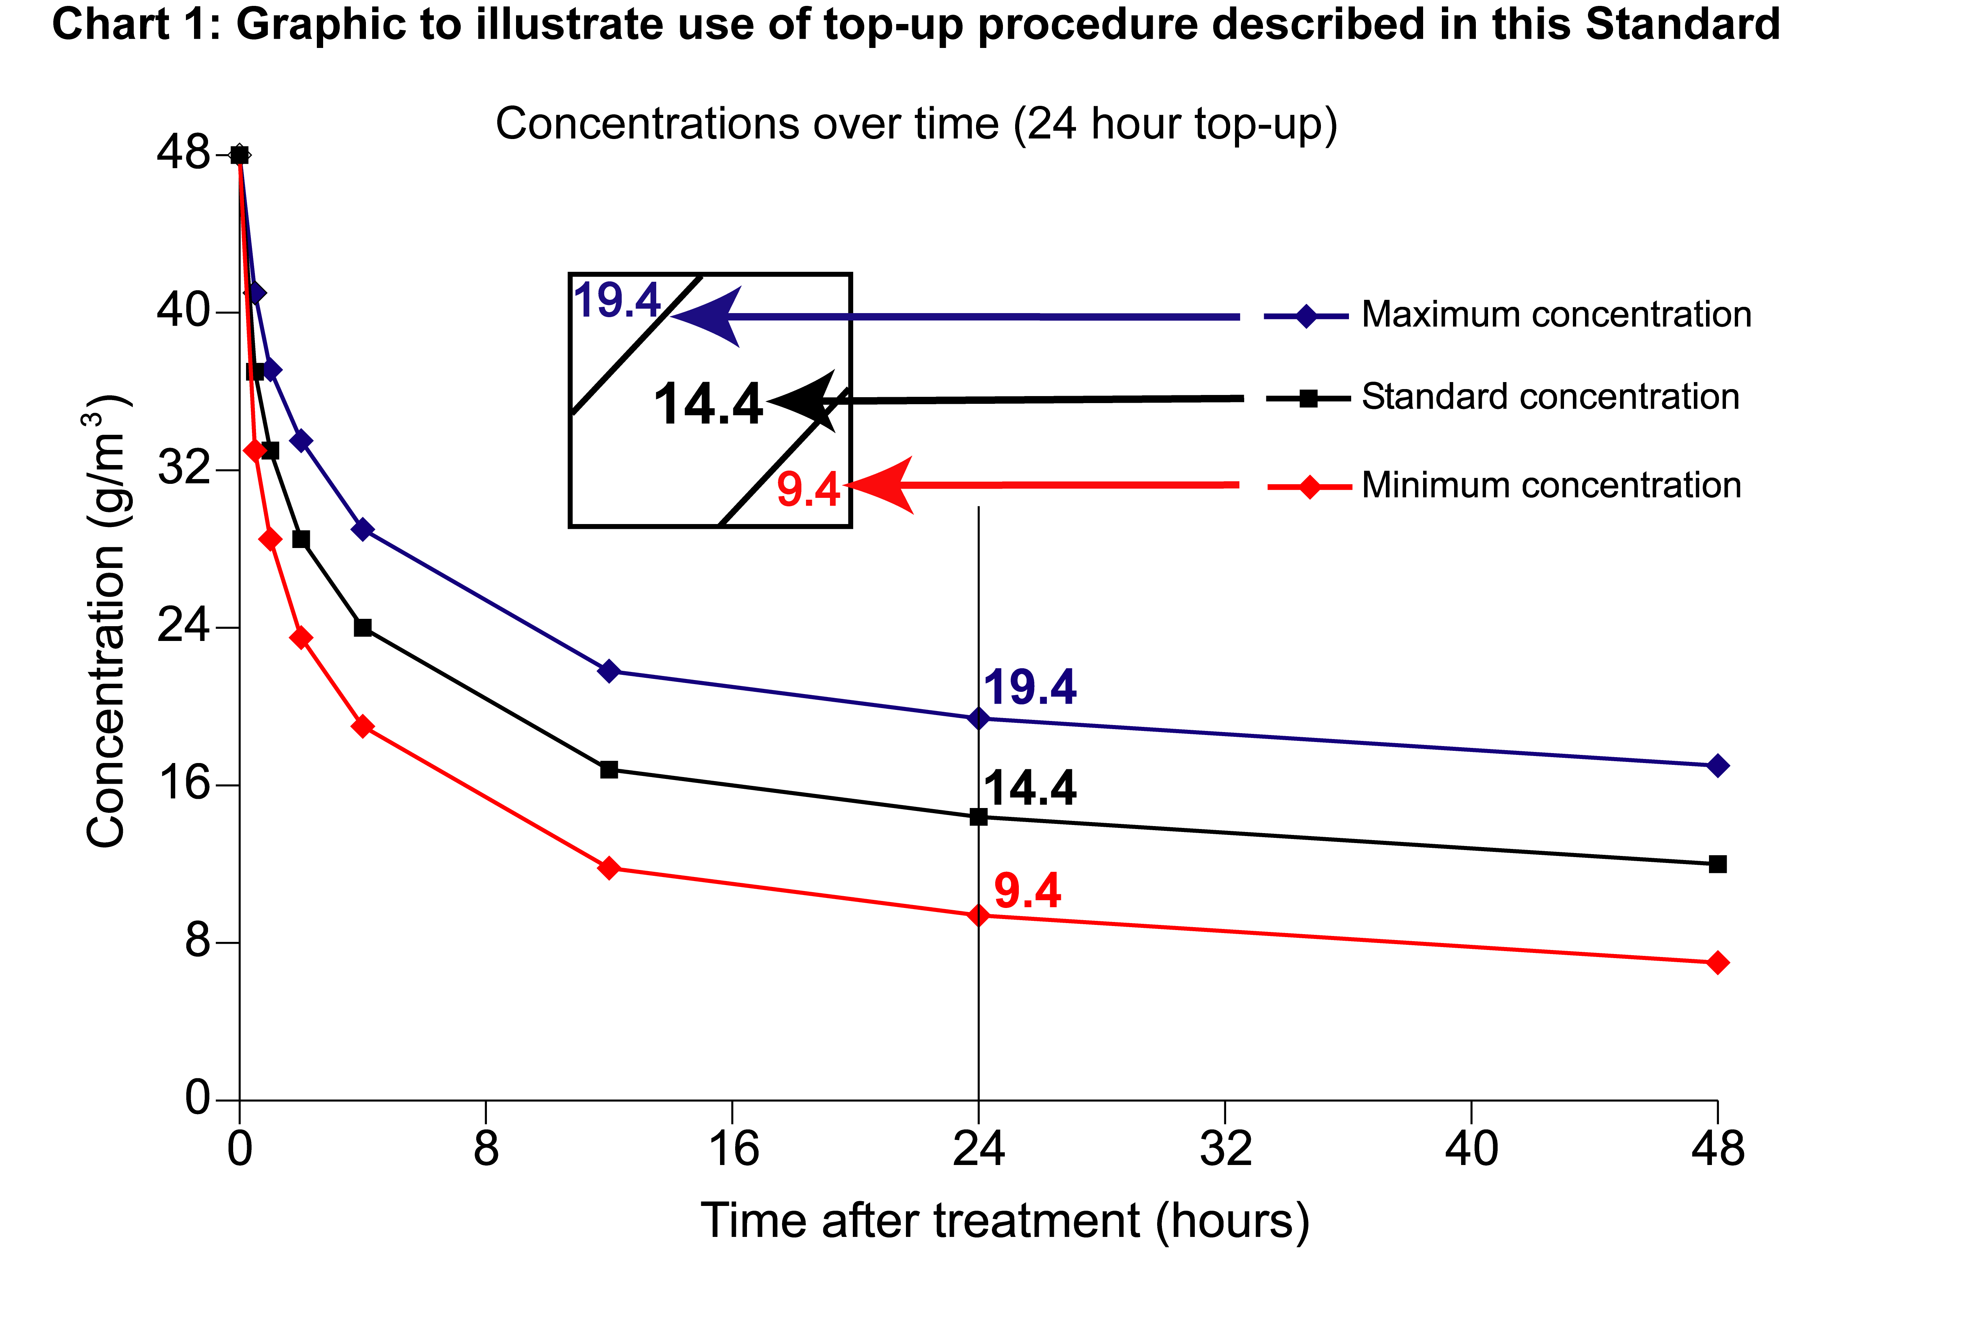

Chart 1 graphically shows what should happen to methyl bromide levels during a well-sealed, sheeted fumigation, based on the values in Table 3. and an initial dosage of 48g/m³. Also shown are the boundaries around the standard concentration, below which the fumigation will not be acceptable. The middle line (standard concentration represents the theoretical progress of a fumigation treatment in a well-sealed sheeted fumigation enclosure.

The middle line is the AQIS STANDARD CONCENTRATION (value A in the Methyl Bromide Fumigation Ready Reckoner).

The lower boundary is the Minimum concentration to allow top-up (value B in the Methyl Bromide Fumigation Ready Reckoner).

The upper boundary is the Maximum top-up concentration (value C in the Methyl Bromide Fumigation Ready Reckoner).

If the methyl bromide concentration falls below the minimum concentration then the fumigation has failed and a TOP-UP MAY NOT BE CARRIED OUT.

Example 1 – Top-up at the end of the fumigation period

Fumigation has been carried out, applying methyl bromide at 48 g/m³. At 24 hours the lowest fumigant concentration at the monitor points is 12 g/m³.
48 g/m³ @ 24 hours

12 g/m³ is below the AQIS Standard for 48 g/m³ at 24 hours (14.4 g/m³, as shown, centre figure) but above the Minimum Concentration to allow top-up (9.4 g/m³ as shown, bottom right figure).

The AQIS Standard allows for the fumigant concentration to be topped-up to the Maximum Top-Up Concentration (19.4 g/m³ as shown, top left figure).

To determine the amount of fumigant to be added to the enclosure, subtract the lowest concentration from the maximum top up value, as shown below:

19.4 - 12 = 7.4 g/m³ x volume of the enclosure

This figure is multiplied by the volume of the enclosure to determine the total dosage to be applied. The fumigant should be evenly distributed to the entire enclosure, using a vaporiser, with fans operating.

The fumigation period must be extended by 4 hours, at which time ALL monitor points must read at or above the standard (for the 24 hour standard figure).

Where any concentration has dropped below the standard, only one top-up procedure is permitted.

Example 2 – Continuous top-up during the fumigation period
48 g/m³ @ 12 hours
Fumigation has been carried out, applying methyl bromide at 48 g/m³. At 12 hours the lowest fumigant concentration on the monitor tubes is 17 g/m³.

It is suspected that fumigant levels may drop below standard by the end of the fumigation and a decision to top-up is made.

The AQIS Standard allows for the fumigant concentration to be topped-up to the Maximum Top-Up Concentration (21.8 g/m³ as shown, top left figure).

To determine the amount of fumigant to be added to the enclosure, subtract the lowest concentration from the maximum top up value, as shown below:

21.8 - 17 = 4.8 g/m³ x volume of the enclosure

This figure is multiplied by the volume of the enclosure to determine the total dosage to be applied. The fumigant should be evenly distributed to the entire enclosure, using a vaporiser, with fans operating.

No extension of the fumigation period is required, as long as the concentration has not fallen below the standard. Multiple top-up actions may take place where the concentration has not fallen below the standard.
APPENDIX 13: Methyl bromide as a quarantine fumigant

Methyl bromide fumigation has been used globally as a disinfestation treatment for many years. It has a reputation for effectiveness against a wide range of pests and commodity combinations. It is favoured in many countries for plant quarantine because of its reputation for having:
- Good penetrating ability;
- Rapid action;
- High toxicity to a broad spectrum of insects and similar pests.
It is frequently used for treating timber, agricultural products, empty containers, foodstuffs, seeds and plants.

Due to its recognised effectiveness and the lack of well-tested alternatives, AQIS currently uses methyl bromide extensively for preventing exotic pest incursions into Australia. Methyl bromide is equally important as a treatment allowing Australian exporters to meet the importing requirements of other countries.

AQIS aims to minimise methyl bromide use where possible, due to its damaging effect on the ozone layer and the likelihood that it may be phased out completely. (see Appendix_14: Methyl Bromide as an Ozone Depleting Gas). This includes encouraging the efficient use of methyl bromide at minimum effective application rates and avoiding re-treatments by providing comprehensive and accurate information on treatment requirements.

Safety and methyl bromide formulations

Methyl bromide is an extremely toxic, odourless gas. Regulations in some countries may specify that methyl bromide used in fumigation treatments must contain a warning agent. This is typically 2% chloropicrin. However, methyl bromide with chloropicrin is phyto-toxic to live plants, cut flowers, fresh fruit and vegetables and seeds. In Australia chloropicrin residues are not permitted in many foodstuffs.

NOTE
In some situations the chloropicrin may condense and pool, increasing the health and safety hazards associated with the use of methyl bromide.

APPENDIX 14: Methyl bromide as an ozone depleting gas

At a meeting of signatories to the Montreal Protocol in November 1992, methyl bromide was listed as a category 1 ozone depletant. This decision was made due to concern that methyl bromide’s continued use would threaten the integrity of the ozone layer. This is a major environmental concern as the depletion of the ozone layer allows greater amounts of ultra violet (UV) radiation to reach the surface of the Earth. Subsequently, developed countries have agreed to progressively phase out the general use of methyl bromide by the year 2005 (except for quarantine and specific exemption purposes) and developing countries by 2015.

In recognition of the importance of methyl bromide as a quarantine tool, without alternatives in many cases, an international exemption on phase out for quarantine purposes has been agreed to for the time being. However, it is likely that as the agricultural use of methyl bromide is phased-out the costs of producing methyl bromide will increase substantially, and the gas may become increasingly difficult to obtain. As a result, and despite the current exemption, it is likely that methyl bromide has only a limited future for quarantine purposes.

AQIS recognises the ozone depleting properties of methyl bromide and seeks to actively promote reduced methyl bromide use, within the constraints of quarantine protection, through:

- Encouraging effective use of treatments with this fumigant at minimum effective application rates;

- Advising its client industries of acceptable alternatives to methyl bromide where available;

- Encouraging quality assurance practices that minimise reliance on end-point treatments as the primary measure to reduce quarantine risks associated with pest infestation in goods.

Australia supports the use of technologies that recycle or trap methyl bromide, preventing it from escaping into the atmosphere providing all other requirements of the AQIS Methyl Bromide Standard are met.

Suppliers and users of methyl bromide need to be aware that importing this gas into Australia without a licence, is prohibited under the Commonwealth's Ozone Protection Act 1989.
APPENDIX 15: Glossary of terms
Term | Definition
Ambient temperature | Temperature of the air immediately surrounding the fumigation enclosure.
Chloropicrin | A strong-smelling chemical commonly added to the odourless methyl bromide to indicate the presence of gas.
Commodity | The item or goods that are being exported or targeted for fumigation.
Concentration | The amount of fumigant present at a certain point in the fumigation enclosure, usually expressed as grams per cubic metre (g/m³)
Consignment | Refers collectively to the commodity, any packing materials used and the mode of transport such as a freight container.
Container  (freight container) | Standardised transportation units intended to be suitable for transporting a variety of commodities.
Dosage | The calculated amount of fumigant applied to a fumigation enclosure, usually expressed as kilos or grams.
Dry dock | Narrow basin, trench or area that may be flooded and is large enough to hold a vessel. After flooding, the basin is able to be sealed from the body of water and emptied of water to allow work to be carried out on the vessel.
Dunnage | Materials used for supporting or protecting commodities during transportation.
External timber | Any timber components used in construction or fittings of the yacht e.g. railings, non-slip strips on deck.
Free air space | Empty space between, above or around a commodity to allow the fumigant access to the commodity to eradicate pests.
Fumigant | A chemical, which at a particular temperature and pressure can exist in a gaseous state in sufficient concentration and for sufficient time to be lethal to insects and other pests.
Fumigant supply pipe | A relatively large diameter pipe used to supply fumigant to a fumigation enclosure.
Fumigation | Application of a fumigant to a fumigation enclosure to eradicate pests.
Fumigation certificate | Documentation certifying that a fumigation treatment has been undertaken in compliance with AQIS requirements.
Fumigation chamber | A permanent chamber used for fumigation purposes that meets the AQIS pressure test requirements.
Fumigation enclosure | Any space or area designed to contain fumigant for the purposes of fumigation. Examples include gas-tight containers, gas-proof sheets sealed to an impermeable floor with sand or water snakes, and purpose built structures.
Fumigation sheets | Gas impervious material (generally made from vinyl, coated nylon or polyethylene) capable of creating a temporary fumigation enclosure (also known as tarps or tarpaulins).
Gas equilibrium | At the start of fumigation, where the gas concentration at each monitoring point is within 15% of the lowest reading. AQIS only accepts that a fumigation exposure has started AFTER it has been demonstrated that equilibrium has been achieved and concentrations at all monitoring points are at or above the standard.
Internal timber | Any timber items found inside the yacht e.g. wooden fittings, floors, drawers and panels.
Monitoring tube | A relatively small diameter tube used to withdraw a sample of gas/air mixture from within a fumigation enclosure for measuring fumigant concentration.
Normal atmospheric pressure (NAP) | Standard, natural atmospheric (air) pressure (10⁵ Pa).
Pallet | A platform used to support commodities during shipment generally of standard dimensions to allow for easy stacking. Pallets used in shipping are generally made of timber, plywood, metal, plastic or moulded fibreboard.
Term | Definition
Patent slip | Moveable cradle that is able to slide under the vessel’s keel in the water, then transport the vessel beyond the high tide mark to a work area.
Perishable commodities | Cut flowers, fresh fruit, vegetables and nursery stock.
Permeability | The rate at which a substance (such as methyl bromide) flows through a material (such as a fumigation sheet).
Pest | Any animal, plant or other organism that may pose a threat to the community or the natural environment.
Phytotoxic | Poisonous to plants.
Quarantine pest | A pest of potential economic and/or environmental importance to an area where it is not yet present, or is present but not widely distributed and is being officially controlled.
Risk area | Any area in proximity to a fumigation enclosure into which fumigant may escape in hazardous concentrations as determined by local legislation relevant to fumigation practice in the location in which the treatment is performed. May also be referred to as ‘danger area’.
Sand snake | Sand filled tubes approximately 1 metre long used as weights to hold fumigation sheets in place during fumigation.
Sealed vessel | Yacht or vessel that may be effectively sealed to retain gas pressure as per the AQIS pressure testing requirements (see Section 4.2, 4.3 and Appendix 5).
Sheet fumigation | A process of creating a gas-tight enclosure by covering/enclosing the commodities to be fumigated under a gas proof sheet, which is sealed to an impermeable floor (generally using sand or water snakes).
Sheeted vessel | Yacht or vessel that has been covered by a fumigation sheet that meets AQIS requirements (see Section 4 and 5, Sheet fumigation).
Sorption/sorptive | The uptake of a fumigant by any material being treated with a fumigant. This may be reversible (unchanged fumigant may be released on ventilating) or irreversible (leading to residues of fumigant or breakdown of products in the commodity).
Threshold Limit Value (TLV) | TLV is the maximum concentration of fumigant that a worker can be repeatedly exposed to in the workplace without harmful effects. This figure is based on an 8 hour day, 40 hour working week and is currently 5ppm in Australia.
Timber (also known as lumber) | A term of commerce for wood, either as logs or sawn units.
Under gas | Term used to describe container(s) that do not have documentation that states that the container has been ventilated to TLV (5ppm in Australia).
Uniform gas distribution | See gas equilibrium.
Water snakes | Water filled tubes used as weights to seal fumigation sheets to the floor. These perform the same function as sand snakes. Water snakes are much longer and wider than sand snakes.
Yachts | Non-commercial vessels of any dimension for private use, either powered or under sail.

